**PRODUCT BACKLOG REFINEMENT-SPRINT 2**



**Date:30/12/2016**

Contents

1. MEETING OBJECTIVES 3

2. ATTENDEES 3

3. CONTENT 3

4. EVIDENCE 4

4 APPROVAL OF MEETING 4

**The meeting begun at 1:30 pm**

# MEETING OBJECTIVES

Estimate user story Sprint 2

# ATTENDEES

|  |  |  |
| --- | --- | --- |
| **Name** | **Roles** | **Email** |
| Nguyen Bao Thach | Team leader | b.thach511@gmail.com |
| Nguyen Hoang Nam Phuong | Team member | nguyenhoangnamphuong2110@gmail.com |
| Dang Quoc Viet | Team member | vietdang.2509@gmail.com |
| Tran Phan Trung Chanh | Team member | hunteratthenight@gmail.com |
| Nguyen Dang Quang | Team member | ndq.quang511@gmail.com |
| Nguyen Huu Tai | Team member | Nguyenhuutai1995k19t01@gmail.com |

# CONTENT

|  |  |  |
| --- | --- | --- |
| **ID** | **Description** | **Note** |
| 1 | Estimate user story |  |

# EVIDENCE

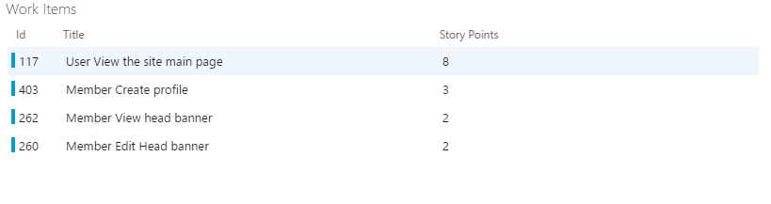

# APPROVAL OF MEETING

|  |  |
| --- | --- |
| **Name** | **Signature** |
| Nguyen Bao Thach (Team leader) |  |

**The meeting was finished at 4:30pm**